**Project 4 Part 2 Graham Scan Hull**

Name: Randy Fu Period: 5 Date: 12/10

Is your lab name l042?(lowercase L followed by digits 042) Yes

Did you created a class to store a point? Yes

Did you use a vector to store the points you generated? Yes

Did you use a stack to store the points that form the convex hull? Yes

Did you sort using the sort method offered by C++? Yes

Did you use at least one stack? Yes

Does your main method contain only a call to part2? Yes

Paste here 4 clear picture of the ppms that you obtained by running your application 2 times with both part1 and part2 activated. Each point on this graph should be graphed as a small circle (radius 2 or 3) and the convex hull you obtained should be on the graph too. (if you wish you may use colors)

Run1:

-quichull.ppm:

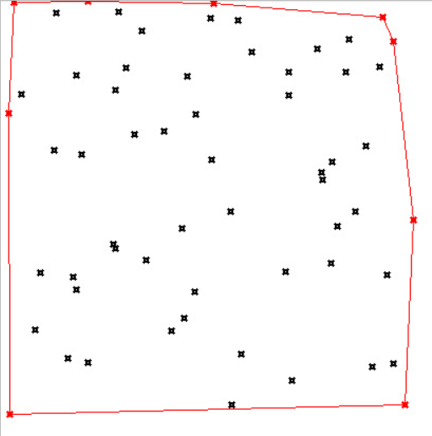

-grahamscan.ppm:

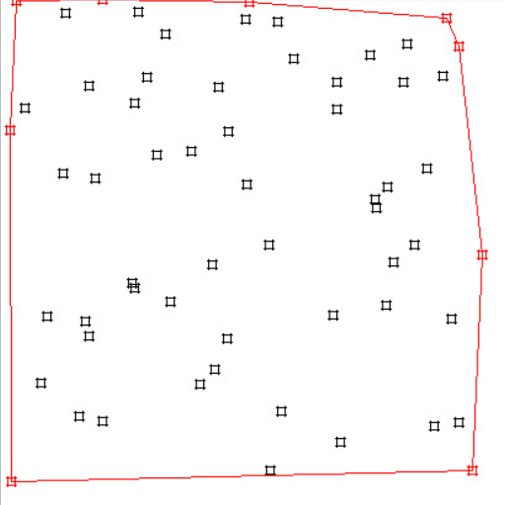

Run2:

-quichull.ppm:

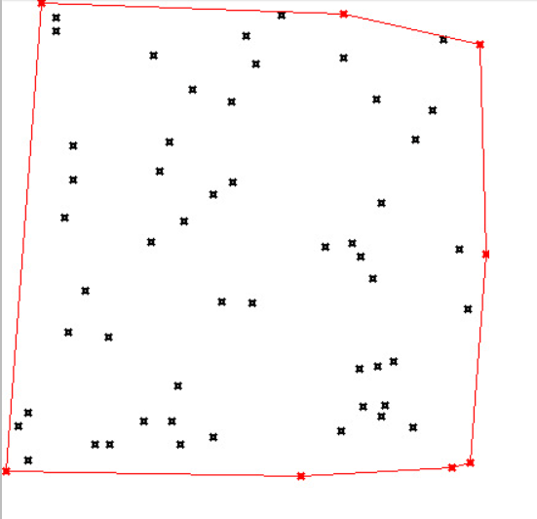

-grahamscan.ppm:

